# Database Schema for Taskflow API

Step 1 . Create Database
- Create database taskflow_db;
Step 2. Use Database
- Use taskflow_db;
Step 3. Create a Class ( @Entity) - Inside Eclipse IDE

- User Table
CREATE TABLE users (
id BIGINT PRIMARY KEY AUTO_INCREMENT,
name VARCHAR(100) NOT NULL,
email VARCHAR(150) UNIQUE NOT NULL,
password VARCHAR(255) NOT NULL,
role VARCHAR(50),
created_at TIMESTAMP DEFAULT CURRENT_TIMESTAMP
);

-- Task Table
CREATE TABLE tasks (
id BIGINT PRIMARY KEY AUTO_INCREMENT,
title VARCHAR(150) NOT NULL,
description TEXT,
status VARCHAR(50) NOT NULL,
priority VARCHAR(50) NOT NULL,
user_id BIGINT,
created_at TIMESTAMP DEFAULT CURRENT_TIMESTAMP,
FOREIGN KEY (user_id) REFERENCES users(id)
);

Step 4. Show Tables
- Show tables;

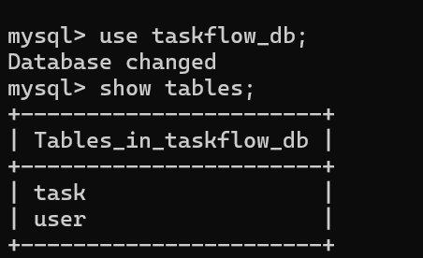

Step 5. Desc Table
- desc user;

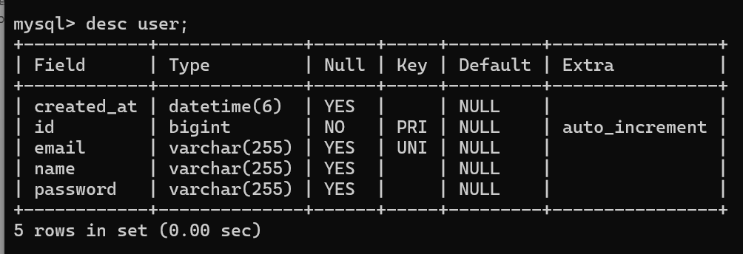

- desc task;

